Year 10 Science (Adjusted)
Semester 1 Examination Revision 2019
Physical Sciences

1. What is the difference between distance and displacement? Draw a diagram to help your explanation.

2. Complete the following table. Make sure you include the appropriate units for each quantity.

Distance travelled | Time taken | Average speed
400 m | 45 s
3000 km |  | 600 km/h
 | 25 s | 30 m/s
200 m |  | 25 m/s

3. For each ticker tape shown, describe the motion of the body to which the tape was attached. The left-hand dot is at time zero.

(a)



(b)



4. A man drives his car 800 m due East and then turns North, driving 300 m before stopping at a petrol station. It took him 120 s to get there.

(a) What distance he has driven.

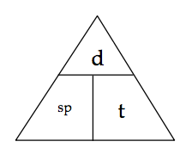

(b) Calculate his average speed for the journey.


5. A balloon filled with hydrogen gas has a velocity of 40 m/s East. How long will it take to go 450 m ?


6. What is the average speed of a plane if it flies 2700 km in 2.3 hours? Give the answer in km/h.

7. Use the scale in the map below to work out the distance and displacement from the Fairmont Empress hotel to Craigdarroch Castle. Use either the blue or grey route.

Remember to give a bearing or direction for the displacement.

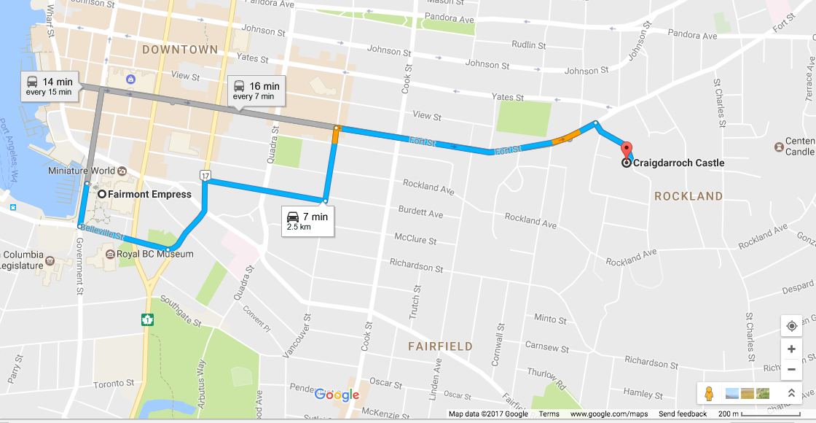

distance:

displacement:

